Tool 41: Visioning
Aim of the tool
To generate a common goal, hope, encouragement, creative thinking and passion.
When to use it?
The co-creation stage, when the emphasis shifts towards developing group outputs.

What is Visioning?
Visioning is a tool that brings stakeholders together to develop a shared vision of the future. It helps to answer the question:
“What do we want to see in place 5-10 years from now in this MSP?”
By engaging participants in the formulation of a common goal, visioning gives people a sense of control and motivation, and offers a possibility for fundamental change. It nurtures essential characteristics of powerful and effective groups, like cohesion and common direction.
With problem solving, a group can become mired in technical details and political problems and may even disagree on how to define the problem. Problem solving, although useful, rarely results in any real fundamental change.
While a problem is something negative to move away from, visioning provides a positive paradigm by offering something to move toward. It offers a bigger picture. It generates creative thinking and passion to solve the problems that might arise when moving toward a vision.
A good vision is both realistic and stretching. Visioning too far into the future has the drawback of not creating enough motivational pull. Visioning too close to today and has the drawback of appearing as just another plan.
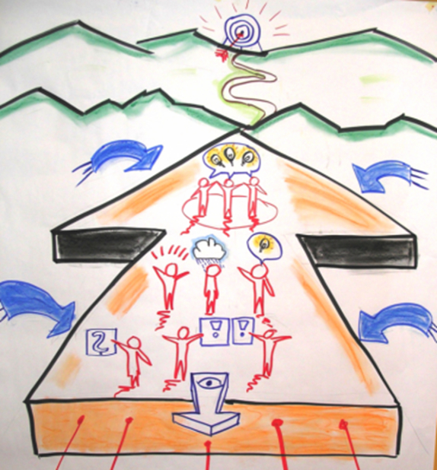
Source: www.sswm.info/content/visioning
How to facilitate visioning group work
As a group formulate the vision as an answer to the question: “What do we want to see in place 5-10 years from now in this MSP?”
Step1: Context
- Imagine there will be a documentary team coming to your organization to show them the progress that has been made by all the stakeholders.
- What will you show them?
- What activities will they see?
- What achievements have been made?
- How do outside organizations collaborate?
- What institutions, attitudes, paradigms have been changed?
- What are the livelihoods of the people?
Step 2: Brainstorm
- Individually, on a piece of paper list the elements of your vision, the concrete things you see in the future, and the things you dream about. Through this process do not yet talk to your neighbours.
- In pairs, agree on the 5 most important concrete elements of the vision and mark the two most important ones. Then share your ideas in plenary.
Step 3: Grouping of ideas
- Which ideas go together because they have the same intention, the same direction?
Step 4: Naming the vision elements
- Give a short name to each of the groups of ideas that will form the vision.
- What is the common direction, and the key element of these ideas?
- How can we name this element of the vision?
Step 5: Reflect
- How do these elements link to each other?
- Are they all important or is there a hierarchy?
- Could we come up with a one sentence vision, or could we keep these separate elements of the vision as they are?

Learn more
Several visioning exercises as well as guidelines and best practices. Access here
DFID (Editor) (2003): Tools for Development. A handbook for those engaged in development activity. London: Department for International Development. URL, pdf.
Social Transformation Project. Visioning Toolkit. Access here

